FSC TOOLKIT FOR HARDWOOD SAWMILLS
OVERVIEW
Offered by:

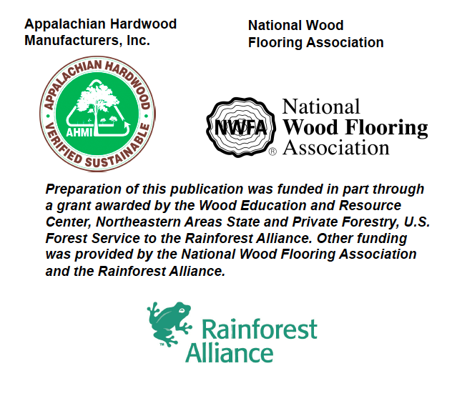
Lead author:
Jason Grant Consulting
www.jasongrantconsulting.com
The National Wood Flooring Association (NWFA) exists to advance, promote and educate the wood flooring industry. An international trade association with more than 3,000 members, NWFA represents the entire supply chain including manufacturers, distributors, dealer/contractors, retailers, and service organizations. www.nwfa.org

Appalachian Hardwood Manufacturers, Inc. (AHMI) is a trade association of hardwood sawmills, concentration yards, wholesalers and secondary manufacturers who offer logs, lumber and products from the Appalachian Hardwood Forest. www.appalachianhardwood.org

The Rainforest Alliance works to conserve biodiversity and ensure sustainable livelihoods by transforming land-use practices, business practices and consumer behavior. www.ra.org

In accordance with Federal law and U.S. Department of Agriculture policy, this institution is prohibited from discriminating on the basis of race, color, national origin, sex, age, or disability. (Not all prohibited bases apply to all programs.)

To file a complaint of discrimination, write USDA, Director, Office of Civil Rights, Room 326-W, Whitten Building, 1400 Independence Avenue, SW, Washington, DC20250-9410 or call (202) 720-5964 (voice and TDD). USDA is an equal opportunity provider and employer.
Important Note
Standards change with time, and FSC is no exception. The contents of this toolkit are current with FSC standards and policy as of September 1, 2011.
Purpose of the FSC Hardwood Sawmill Toolkit
This toolkit has been designed to assist hardwood sawmills based in the Appalachian forest region of the U.S. in preparing for successful audits to the FSC Chain of Custody Standard (FSC-STD-40-004) as well as to the FSC Controlled Wood Standard (FSC-STD-40-005).
Using the Toolkit
Due to the length, number and complexity of its components, this toolkit has been broken into parts or components. These are sequenced in an order that is logical for most users. Also, some users will not be interested in all available toolkit components – for example, companies that are not interested in getting certified to the FSC Controlled Wood standard can ignore those components.
When you order this toolkit from AHMI or NWFA, you gain access to all available components which you may request all at once or sequentially as you need them.
Overview of Toolkit Components
1) Guidance on FSC CoC certification
a) The basics of FSC along with an explanation of what is required to prepare for a successful FSC chain of custody (CoC) audit
b) FSC trademarks, labels, product groups, claims, and control systems - what they are, how they are related, and how this applies to hardwood sawmills
c) Buying FSC-certified logs from loggers
2) Sample FSC CoC Written Procedures for a “typical” hardwood sawmill
a) These procedures will need to be tailored to the specifics of your operation
3) Guidance on certification to the FSC Controlled Wood standard
a) An overview of the purpose and function of FSC Controlled Wood in the FSC system and in the manufacture of FSC Mix products
b) An explanation of what is required to prepare for a successful audit to FSC’s Controlled Wood standard
c) An overview of options for providing evidence of the origin of wood that one wishes to control

4) Sample written procedures & forms for FSC Controlled Wood
a) These procedures are designed to be appended to CoC procedures for companies wanting to get certified to the FSC Controlled Wood standard
b) Also includes a sample Controlled Wood policy statement and a sample supplier declaration for documenting district of origin for Controlled Wood, including suggested language for assessing the logical supply area for “original log buyers” (see guidance document for detail)
5) Sample Controlled Wood risk assessments for states in the Appalachian forest region
a) Sample risk assessments are available for each of the following states: Alabama, Georgia, Kentucky, Maryland, New York, North Carolina, Ohio, Pennsylvania, South Carolina, Tennessee, Virginia, West Virginia

